Name………………………………………………………......... Index number…………………..
Candidate’s signature.………………….. Date……………………
233/2
CHEMISTRY (THEORY)
PAPER 2
JULY 2025
2 HOURS

SULIMO JOINT EXAMINATION
Kenya Certificate of Secondary Education (KCSE)

INSTRUCTION TO CANDIDATES
- Write your name and index number in the spaces provided above.
- Sign and write the date of examination in the spaces provided above.
- Answer ALL the questions in the spaces provided in the question paper.
- KNEC Mathematical tables and silent non-programmable electronic calculators may be used.
- All working MUST be clearly shown where necessary
- This paper consists of 14 printed pages.
- Candidates should check the question paper to ensure that all pages are printed as indicated and no questions are missing.
- Candidates should answer all the questions in English.

For Examiner’s Use Only
Question | Maximum Score | Candidate’s Score
1 | 13
2 | 10
3 | 8
4 | 12
5 | 11
6 | 13
7 | 13
TOTAL SCORE | 80

- a) The grid below represents a section of the periodic table. Study it and answer the questions that follow.

 |  |  |  |  |  |  |  | Q
A |  |  |  | C | Z | H | J
B | W |  | R |  | E | P | X
M |  |  |  |  |  |  | Y
- Give the type of bond formed when elements W and Z react. Give a reason for your answer .(2marks)
......................................................................................................................................................................................................................................................................................................................................................................................................................................................................................................................................................................................................................
- Explain the difference in atomic and ionic radii of element Y . (2marks)
......................................................................................................................................................................................................................................................................................................................................................................................................................................................................................................................................................................................................................
- How do the atomic radii of B and W compare? Explain (2marks)
......................................................................................................................................................................................................................................................................................................................................................................................................................................................................................................................................................................................................................
- X grams of W reacted completely with 240cm³ of Gas H . Determine the mass of X that reacted (M.G.V=22,400cm³,W=24) (3marks)
................................................................................................................................................................................................................................................................................................................................................................................................................................................................................................................................................................................................................................................................................................................................................................................................................................................................................................................................

b) Table I gives some information about period 3 elements. Use it to answer the questions that follow.
Element | A | B | C | D | E | F | G | H
No of protons | 11 | 12 | 13 | 14 | 15 | 16 | 17 | 18
Melting point |  |  |  |  | 442  590 | 113  119
Boiling Point

c) Choose two substances that is a gas at room temperature. Give a reason. (2 marks)
…………………………………………………………………………………………………………………………………………………………………………………………………………………………............................................................................................................................................
d) Explain why the element represented by letter E has two melting point values. (1 mark)
……………………………………………………………………………………………………………………………………………………………………………………………………………………………………………………....................................................................................................
e) Element G was dissolved in water and a piece of blue litmus paper was put into the resulting solution. State and explain the observation that was made on the litmus paper.
(2 marks)

...............................................................................................................................................................................................................................................................................................................................................................................................................................................................................................................................................................................................................................................

- Study the scheme below and use it to answer the questions that follow.

Step V Step W
CH3CH = CH2
CH3CH2 COOCH3
CH3CH2COOH
Product T + Na2CO3
CH3CH2COONa
CH3CH2CH2OH
Gas F
CH3CH2CH3

P
NaOH

Polymer K
Step J

NaOH+Heat

K₂CO₃
Step R
G
Step X

- Name the following compounds Product T (1mk)
………………………………………………………………………………………………
- State the condition and reagent used in (2 marks)
REACTION | REAGENT | CONDITION
Step V
Step R

- Name substance G (1mark)
………………………………………………………………………………………………
- State one use of substance G. ( 1mark)
......................................................................................................................................................................................................................................................................................................................................................................................................................................................................................................................................................................................................................
- i) Name and draw polymer K. (2marks)

- Give one environmental effect of using Polymer K. (1mark)
………………………………………………………………………………………………
- Write an equation for the
- combustion of compound P. (1mark)
………………………………………………………………………………………………
ii) Step X. (1mark)
………………………………………………………………………………………………
- Describe how compounds CH₃CH₂COOH and CH₃CH₂CH₂OH can be distinguished chemically. (2marks)
………………………………………………………………………………………………
………………………………………………………………………………………………
………………………………………………………………………………………………
………………………………………………………………………………………………
- The flow chart below represents some industrial processes leading to the formation of two nitrogenous fertilizers.
Zinc Blende
Air
Process 1
Compound A
Catalytic Chamber
Sulphur(iv)Oxide
Process 2
Substance A
Gas Z
Product M
Conc.H₂SO _{4(l)}
Dilution Chamber
Absorption Chamber
Zn
Process 3
Conc.H₂SO _{4(l)}

- Name the (3 marks)
    - Process 2
....................................................................................................................................
    - Gas Z
...................................................................................................................................
    - Substance A
....................................................................................................................................
- Write chemical equation for the reaction in (3 marks)
- Process 1
.......................................................................................................................................
- Process 2
.......................................................................................................................................
iii. Process 3
.......................................................................................................................................
- State two optimum conditions in the catalytic chamber (2 marks)
.................................................................................................................................................................................................................................................................................................................................................................................................................................................................. ......................................................................................................................................................

- Why is gas Z dissolved in the Concentrated Sulphuric(VI) acid in the dilution chamber (1mark)
................................................................................................................................................................................................................................................................................................................................................................................................................................................................................................................................................................................................
- State one use of ( 2 marks)
- Zinc metal
..................................................................................................................................................................................................................................................................................................................................................................................................................................................................
................................................................................................................................................
ii. Sulphuric (VI)acid
..................................................................................................................................................................................................................................................................................................................................................................................................................................................................
................................................................................................................................................
- (a) Define the following terms Solubility (1mark)
................................................................................................................................................................................................................................................................................................
................................................................................................................................................

b) The solubilities of potassium nitrate and potassium bromide at different temperatures was determined. The following data was obtained.

Temperature ⁰C |  | 0 | 10 | 20 | 30 | 40 | 50 | 60 | 70 | 80
Solubility g/100g H₂O | KNO₃ | 5 | 15 | 26 | 43 | 61 | 83 | 105 | 135 | 165
Solubility g/100g H₂O | KBr | 50 | 55 | 60 | 65 | 70 | 77 | 85 | 90 | 95

- Plot a graph of solubility against temperature for both salts on the same axis (3 marks)


- What was the solubility of each salt at 65⁰C (1 mark)
…………………..…………………………………………………………………………
- 100g of a saturated solution of potassium nitrate at 70⁰C was cooled to 20⁰C. What mass of the salt will be crystallized? (2 marks)

....................................................................................................................................................................................................................................................................................................................................................................................................................................................................................................................................................................................................................................................................................
iii. Determine the concentration of potassium nitrate in moles per litre when the two salts are equally soluble. (K=39.0, N=14.0, O=16.0) (3 marks)
..............................................................................................................................................................................................................................................................................................................................................................................................................................................................................................................................................................................................................................................................................................................................................................................................................................................................................
iv. State and explain the observations when a mixture of 50g of potassium nitrate in 100g of water and 50g of potassium bromide were heated to 80⁰C and cooled to 30⁰C.
(2 marks)
..............................................................................................................................................................................................................................................................................................................................................................................................................................................................................................................................................................................................................................................................................................................................................................................................................................................................................
5. The standard reduction potentials for five half cells are shown in the table below. Study it and answer the questions that follow. (The letters do not represent the actual symbol of elements).
Elements E^{θ} (Volts)
(i)
(ii)
(iii)
(iv)
(v)

I. (a) With a reason, identify the weakest reducing agent. (1mark)
……………………………………………………………………………………………
(b) Which half-cell is likely to be hydrogen? (1mark)
……………………………………………………………………………………………

(c) Draw an electrochemical cell when two half cells of (II) and (IV) are combined.
(3marks)

(d) Calculate the e.m.f of the cell in (c) above. (1mark)
…………………………………………………………………………………………………
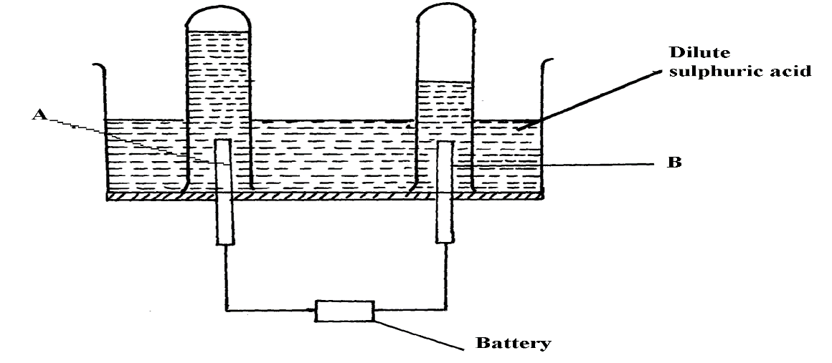
II. 100cm³ of 2M sulphuric acid was electrolyzed using the set up represented by the diagram below;
K
L

- Name gas; (1 mark)
(i) L............................................................
(ii) K..........................................................
- Write the equations for the reactions that produces gas L ; (1 mark)
..................................................................................................................................................................................................................................................................................................................................................................................................................................................................
- Explain the difference in the Volumes of gases produced at the electrodes
(1 mark)
....................................................................................................................................................................................................................................................................................................................................................................................................................................................................................................................................................................................................................................................................................................................................................................................................................................................................................................................................
- During the electrolysis, a current of 0.5 A was passed for 21 minutes and 36 seconds, calculate the volume of gas produced at the anode (1F = 96,500 C, Molar gas volume = 24 dm³ at r.t.p) (3 marks)

....................................................................................................................................................................................................................................................................................................................................................................................................................................................................................................................................................................................................................................................................................................................................................................................................................................................................................................................................
- Study the set up below and use it to answer the questions that follow.

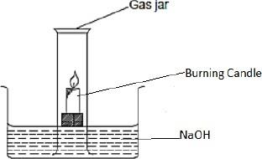

(i) What is the aim of the experiment? (1 mark) .................................................................................................................................................................................................................................................................................................................................................................................................................................................................
(ii) Identify one mistake in the set up above. (1 mark) .................................................................................................................................................................................................................................................................................................................................................................................................................................................................
(iii) After the experiment, the student calculated the volume of air used and found to be 19.2%. Comment on the results. (2 marks)
.................................................................................................................................................................................................................................................................................................................................................................................................................................................................
.....................................................................................................................................................
(b) Another student carried out the same experiment using phosphorous instead of burning candle:
(i) State one modification the student should carry out on the above set up to suit the experiment. (1 mark)
.................................................................................................................................................................................................................................................................................................................................................................................................................................................................
(ii) Describe the above experiment to show how results were obtained. (3 marks) .................................................................................................................................................................................................................................................................................................................................................................................................................................................................
(iii) After the experiment the student added three drops of methyl orange indicator in the trough. State and explain the observation made. (2 marks)
.................................................................................................................................................................................................................................................................................................................................................................................................................................................................
.....................................................................................................................................................

- The following results were obtained in an experiment to determine the heat of neutralization of 50 cm³ 2M HCl and 50 cm³ 2M sodium hydroxide.

Mass of plastic cup = 45.1g
Initial temperature of acid = 27.0ºC
Initial temperature of alkali = 23.0ºC
Mass of plastic cup + HCl + NaOH = 145.1g
Temperature of the mixture of acid and alkali = 38.5ºC.

(a) Define heat of neutralization; {1mark}
.....................................................................................................................................................
.....................................................................................................................................................
.....................................................................................................................................................
..................................................................................................................................................... (b) Write an ionic equation for the neutralization of hydrochloric acid and sodium hydroxide. {1mark} Solution:
.....................................................................................................................................................
.....................................................................................................................................................
.....................................................................................................................................................
..................................................................................................................................................... (c) Calculate;
(i) The amount of heat produced during the experiment. {2mark}
(Specific heat capacity of solution=4.2kjkg⁻¹k⁻¹, density of solution= 1gcm⁻³).
.....................................................................................................................................................
.....................................................................................................................................................
.....................................................................................................................................................
.....................................................................................................................................................
(ii). Molar heat of neutralization for the reaction. {2marks}
..................................................................................................................................................................................................................................................................................................................................................................................................................................................................
(d). Explain why the molar heat of neutralization of NaOH and ethanoic acid of equal volume and molarity would be less than the value obtained in c (ii) above. (1mark)
..................................................................................................................................................................................................................................................................................................................................................................................................................................................................
(e). Write down the Thermochemical equation for the reaction between NaOH and dilute hydrochloric acid above. (1 mark)
..................................................................................................................................................................................................................................................................................................................................................................................................................................................................
(f). Draw an energy level diagram for the neutralization reaction in 4 (c) above. ( 3 marks)

